

Short Exam 1 – Computer Vision 2025

50 mn – No document allowed – The exam will be graded on 10 points.

Part 1: Geometric 2D transformations

Question 1 (4 points - 15 mn): Using homogeneous coordinates, write the matrix form of the following 2D transformations: translation, similarity (rotation+scaling+translation), affine and homography. How many degrees of freedom does each transformation have? How many point correspondences are needed to estimate each?

A similarity transformation consists of rotation, scaling and translation and is defined using conventional Cartesian coordinates as follows:

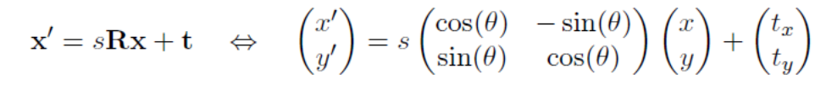
Question 2 (4 points - 20 mn): Describe a procedure for solving the parameters:
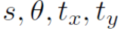
of a similarity transformation from two points correspondences
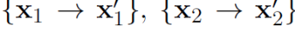

Use the procedure to compute the transformation from the following point correspondences:

(Hint: Drawing the point correspondences on a grid paper may help you to check your answer.)

Question 3 (2 points - 10 mn): Which transformation was applied to the left image to get the right image? Write in homogeneous coordinates the matrix form corresponding to this transformation.

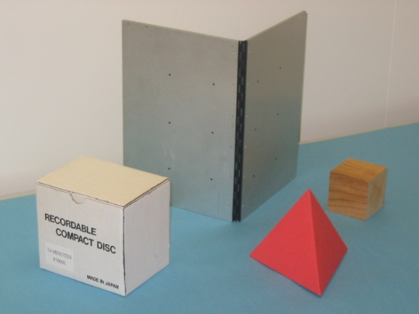 | 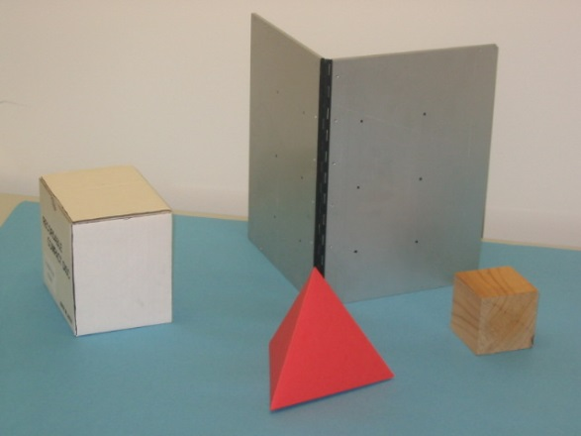
Left Image | Right Image

Question 4 (2 points - 5 mn):: Classify each of the following transformations. Fill-in the circle corresponding to the most specific classification.
